

**Lab Manual- React Export Function ( Props PreBasic)**

**Prepared for**:

**Date:** 18th June 2024

**Prepared by:**

Document Name: Lab Manual **Document Number** SDLab333

**Contributor:**

Contents

1. What are Exports? 3

1. Default export 3

2. Named Exports 3

2. Create Two Module Java script file and Use Default Export 4

3. Named Export 6

# What are Exports?

In **JavaScript**, modules are individual files containing code. This code can be **functions, objects, values, classes, or React** components. The **export** keyword allows these elements to be used in other JavaScript files, thus making the code reusable and modular.

There are two main types of export in React: **named export** and **default export**.

## Default export

A file can have no more than one **default export**. This type of export is commonly used when a file exports only one component.

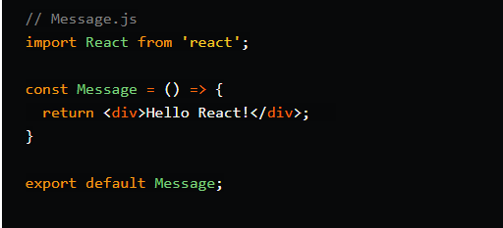

You can import the **Message** component in another file like this:



Note that the **name Message** is arbitrary and can be changed to anything you like



## Named Exports

A file can have as many named exports as you like. Named exports are used when a file exports multiple components or values

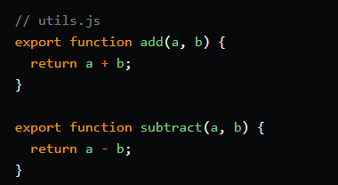

To use these functions in another file, we need to import them using the same names and curly braces:

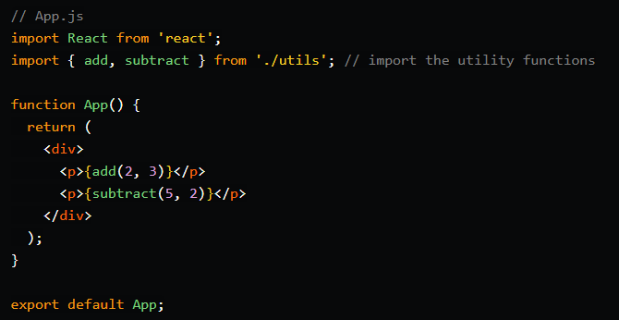

# Create Two Module Java script file and Use Default Export

MJS (ECMAScript Modules): **MJS** is an extension used for JavaScript files that adhere to the ECMAScript Modules (ESM) specification. ECMAScript modules are part of the **JavaScript language** standard and provide a more modern and standardized way to define modules.

* Create two modules files **Module1.mjs** and **module2.mjs**

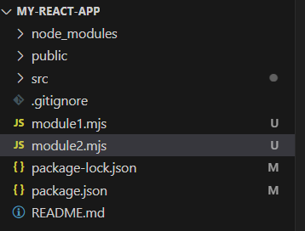

* In **Module1.mjs** lets create four variables as below and do **default export** of only one variable

const a = "David";

const b = "John";

const c = "Vence";

const d = "Lilly";

export default c;

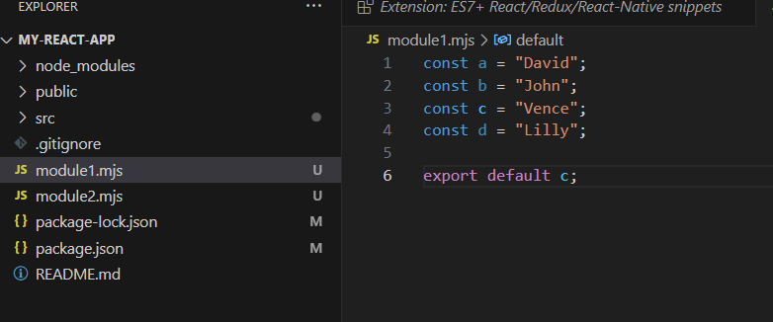

* In **Module2.mjs** Lets import this

import demo from './module1.mjs'

console.log(demo)

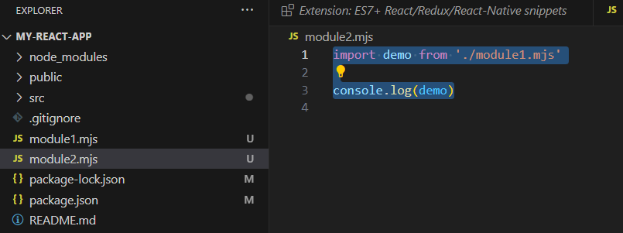

* In the new **command prompt**, Now when you run the **module2** with **node** command this is what you get

**node .\module2.mjs**

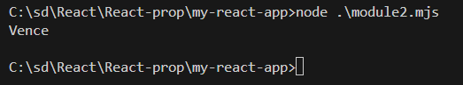

* So, if change **export value** to **b** in moducle1.js another value will print

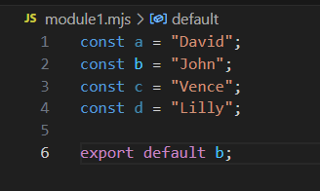

Now Run the same command

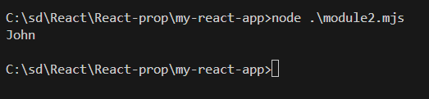

# Named Export

Now we want to export another value as we can simply need to export and then we have to import it as well

* Export all variable value

const a = "David";

const b = "John";

const c = "Vence";

const d = "Lilly";

export default b;

export {a};

export {c};

export {d};

* Import all Variable Value

import demo,{a, c , d} from './module1.mjs'

console.log(demo);

console.log(a);

console.log(c);

console.log(d);

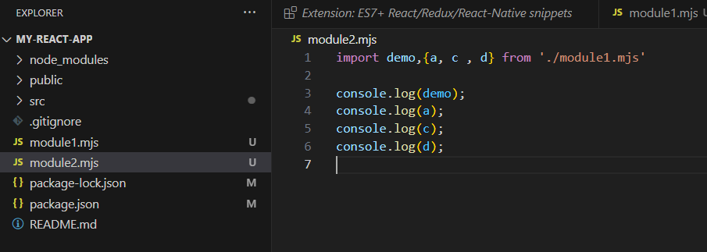

* Now when you run it you get all the value

